nanoRMS：同时定位不同RNA修饰。从头预测Ψ（假尿苷） RNA修饰，并估计不同类型RNA分子中高度和低修饰的Ψ和Nm（2′-O-methylation）位点修饰的化学计量学，包括RNAs、sn/snoRNAs和mRNA
安装：wget https://github.com/novoalab/nanoRMS/archive/refs/tags/v1.0.tar.gz
解压：tar -zxvf v1.0.tar.gz
配置：docker build -f /home/chen/jiangjing/soft/nanoRMS-1.0/docker/Dockerfile . （不用）
修改一下Dockerfile脚本：将里面的sklearn改成scikit-learn

nanoRMS当前环境下可能会有冲突，只能建立一个新的环境安装
conda create nanoRMS
conda activate nanoRMS
conda install bioconda/label/cf201901::ont-tombo
pip install "numpy<1.20" ont_fast5_api matplotlib mappy numba pysam pandas seaborn scikit-learn jupyterlab openpyxl mappy scipy
conda install dask
conda install hdf5 minimap2

java -jar /home/chen/jiangjing/soft/nanoRMS/epinano_RMS/picard.jar CreateSequenceDictionary REFERENCE=Mus_musculus.GRCm39.cds.all.fa OUTPUT= reference.fasta.dict

nanopare数据批量下载：分析基因学院 - 知乎 (zhihu.com)
#检索项目下所有数据
esearch -db sra -query PRJNA523610 | efetch -format runinfo > info.csv
#生成批量处理脚本
cut -d , -f 1 info.csv | grep "SRR" | awk '{print "prefetch "$1 " -O PRJNA523610 "}' >prefetch.sh
#运行脚本
sh prefetch.sh

①构建索引
java -jar /home/chen/jiangjing/soft/nanoRMS/epinano_RMS/picard.jar CreateSequenceDictionary REFERENCE=Mus_musculus.GRCm39.cds.all.fa OUTPUT= reference.fasta.dict
②samtools对Mus_musculus.GRCm39.cds.all.fa构建索引
③碱基位点频率
python3 /home/chen/jiangjing/soft/nanoRMS/epinano_RMS/epinano_rms.py -R /home/chen/jiangjing/soft/nanoRMS/predict_rna_mod/references/yeast_all_rRNA.fa -b /home/chen/jiangjing/soft/nanoRMS/predict_rna_mod/test_data/test.bam -s /home/chen/jiangjing/soft/nanoRMS/epinano_RMS/sam2tsv.jar
其中 -R reference文件必须在fa文件夹下建samtools索引
结果文件：会出一个包含每个碱基位点频率.csv文件

预测RNA修饰位点
环境：当前环境R版本低，需安装版本大于3.5，安装依赖包optparse
①conda uninstall r-base
②conda install conda-forge::r-base
③
install.packages(c("optparse","stringr","dplyr","plyr","VennDiagram","RColorBrewer","data.table","optparse","stringr","dplyr","plyr","VennDiagram","RColorBrewer","data.table","reshape2","ggExtra"))
④CRAN镜子跳不出来解决：chooseCRANmirror(graphics=F)
从头预测（rrna）：
Rscript --vanilla /home/chen/jiangjing/soft/nanoRMS/predict_rna_mod/Pseudou_prediction_singlecondition.R -f WT_rRNA_Epinano.csv -s sn34KO_rRNA_Epinano.csv -t sn36KO_rRNA_Epinano.csv -p ../positions/RNA_Mod_Positions_rRNAYeast.tsv 怎么得到的
结果文件：threesample_predicted_reproducible_y_sites.tsv
venn图：Threesamples_venn_diagramm_mitochondrial.tiff
答：https://github.com/novoalab/nanoRMS/issues/32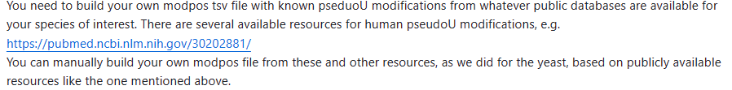
格式：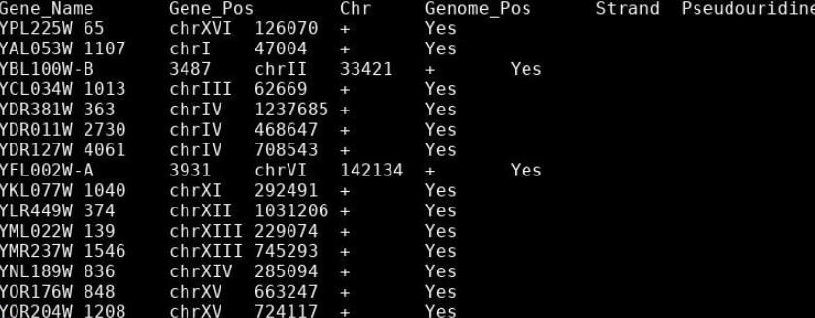

可用数据库:https://rna.sysu.edu.cn/rmbase3/pseudosearch.php或其他已发表论文中的数据

双样本RNA修饰预测
For Transcriptome mapped reads (Reads from one strand)：
Rscript --vanilla ../Pseudou_prediction_pairedcondition_transcript.R -f WT_ncRNA_Normal_Rep1_Epinano.csv -s WT_ncRNA_HeatShock_Rep1_Epinano.csv -p ../positions/RNA_Mod_Positions_ncRNAYeast_HeatSensitive.tsv
结果文件：Paired_comparison_altering_sites_pU_predictions.bed
Paired_comparison_altering_sites_pU_predictions.tsv

For Genome mapped reads (Reads from both strands)：
①csv转bed
../Epinano_to_BED.sh WT_mRNA_Normal_Epinano.csv
②Convert GTF (Only CDS) output into BED
Rscript --vanilla ../GTF_to_BED.R Saccer64.gtf
③Intersect Epinano_BED file and GTF_BED file
bedtools intersect -a ../test_data/WT_mRNA_Normal_Epinano.csv.bed -b Saccer3.bed -wa -wb > WT_mRNA_Normal_Epinano_final.bed
官网给的是错的：
Rscript --vanilla ../Pseudou_prediction_pairedcondition_genome.R -f WT_rRNA_Epinano.csv -s sn36KO_rRNA_Epinano.csv
报错：
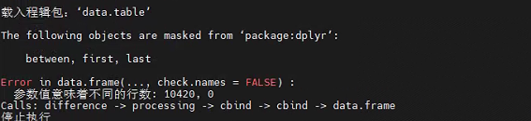
解决：很坑要改脚本
vi ../Pseudou_prediction_pairedcondition_genome.R
mod.file去掉#
脚本：
Rscript --vanilla ../Pseudou_prediction_pairedcondition_genome.R -f WT_mRNA_Normal_Epinano_final.bed -s WT_mRNA_HeatShock_Epinano_final.bed -p ../positions/RNA_Mod_Positions_ncRNAYeast_HeatSensitive.tsv

- RNA modification stoichiometry estimation using Tombo resquiggling
# for rRNA and CC # ~10 minutes
./get_features.py --rna -f cc_yeast_rrna.fa -t 6 -i guppy3.0.3.hac/{CC,*snR,*wt}*/workspace/*.fast5
# for yeast ncRNA # ~10 minutes
./get_features.py --rna -f guppy3.0.3.hac/Saccharomyces_cerevisiae.R64-1-1_firstcolumn.ncrna.fa -t 6 -i guppy3.0.3.hac/*WT??C/workspace/*.fast5
# and link output filescd guppy3.0.3.hac &&
for f in *_WT??C/workspace/batch0.fast5.bam*; do d=`echo $f|cut -f1 -d'/'`; ln -s $f $d.`basename $f|cut -f3- -d"."`; done && ../
结果文件;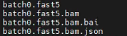
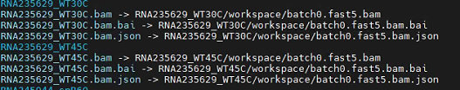

conda install bioconda::nanopolish

zgrep -v X.Ref predictions_ncRNA_WT30C_WT45C.tsv.gz |awk -F'\t' 'BEGIN {OFS = FS} {print $1,$2-1,$2,".",100,"+"}' > predictions_ncRNA_WT30C_WT45C.bed
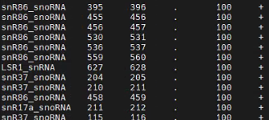
./get_freq.py -f guppy3.0.3.hac/Saccharomyces_cerevisiae.R64-1-1_firstcolumn.ncrna.fa -b results/predictions_ncRNA_WT30C_WT45C.bed -o results/predictions_ncRNA_WT30C_WT45C.bed.tsv.gz -1 guppy3.0.3.hac/*WT30C/workspace/*.fast5.bam -2 guppy3.0.3.hac/*WT45C/workspace/*.fast5.bam

usage: get_freq.py [-h] [--version] [-v] [-1 CONTROL [CONTROL ...]]
[-2 SAMPLE [SAMPLE ...]] [-o OUTPUT] -b BED -f FASTA
[-m MINCOV]
结果文件：zcat predictions_ncRNA_WT30C_WT45C.bed.tsv.gz|less
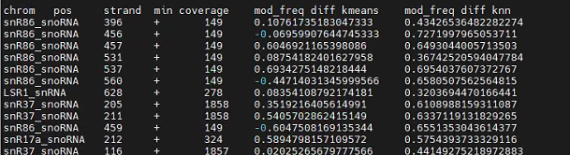
- Visualization of per-read current intensities at individual sites
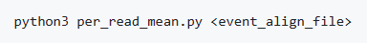
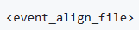：结果文件
python3 per_read_mean.py test_data/data1_eventalign_output.txt
输入输出文件：

Rscript --vanilla nanopolish_window.R test_data/positions.tsv test_data/data1_eventalign_output.txt_processed_perpos_mean.csv data1
输出data1_window_file.tsv：

Rscript --vanilla density_nanopolish.R <window_file1> <window_file2> <window_file3(optional)> <window_file4(optional)>
输出pdf：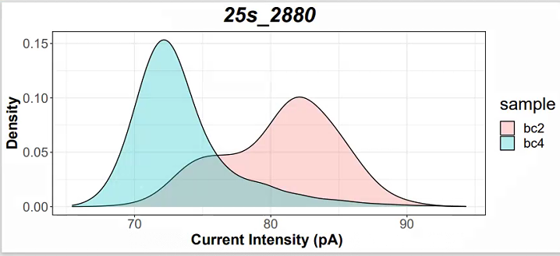

Rscript --vanilla nanopolish_meanlineplot.R <window_file1> <window_file2> <window_file3(optional)> <window_file4(optional)>

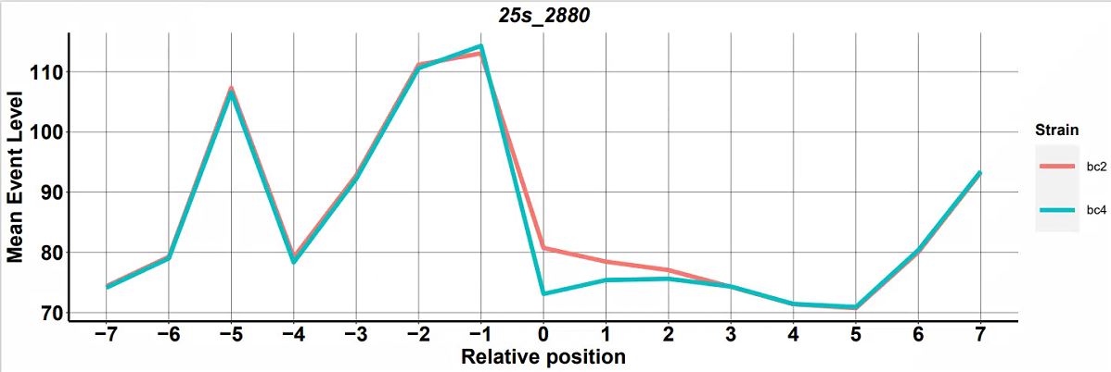

Rscript --vanilla nanopolish_perreadlineplot.R <window_file1> <window_file2> <window_file3(optional)> <window_file4(optional)>
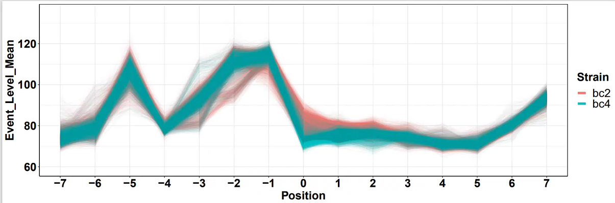

Rscript --vanilla nanopolish_pca.R <window_file1.tsv> <window_file2.tsv> <window_file3.tsv(optional)> <window_file4.tsv(optional)>
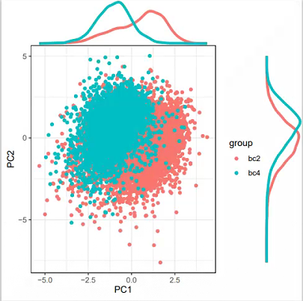

typora
标题:
格式：#+"空格"+标题（输入几个#就代表几级标题，最小六级标题）
快捷键：Ctrl + 数字

删除线:
语法：~~(波浪线)文字~~(波浪线)
快捷键：Alt + Shift + 5

斜体:
语法：*文字* 或 _文字_
快捷键：Ctrl + i

加粗:
语法：**文字** __文字__
快捷键：Ctrl + 文字

斜体+加粗:
语法：***文字*** ___文字___

下划线:
语法：<u>文字</u>
快捷键：Ctrl + u

高亮:
语法：==文字==

下标:
水:H~2~O 双氧水:H~2~O~2

上标:
面积:m^2^ 体积:m^3^

外部跳转:
[百度一下](https://www.baidu.com/)

内部跳转:
[二.Typora的语法](# 二.Typora的语法)

自动连接:
<https://www.baidu.com>

无序列表：- + 空格
有序列表：1. + 空格
引用：> + 空格
标题：ctrl + 数字
表格：ctrl + t
生成目录：[TOC] + 回车
选中一整行：ctrl + l
选中单词：ctrl + d
选中相同格式的文字：ctrl + e
跳转到文章开头：ctrl + home
跳转到文章结尾：ctrl + end
搜索：ctrl + f
替换：ctrl + h
加粗：ctrl + b
倾斜：ctrl + i
下划线：ctrl + u
删除线：alt + shift + 5
插入图片：直接拖动到指定位置即可或者ctrl + shift + i
插入链接：ctrl + k

nanopore测序分析
质控软件安装：
pip install NanoComp
NanoComp -t 12 -o NanoComp -f pdf -n CTR1226CTR1 CTR1226PIC1 --fastq CTR*/fastq/*.fastq.gz
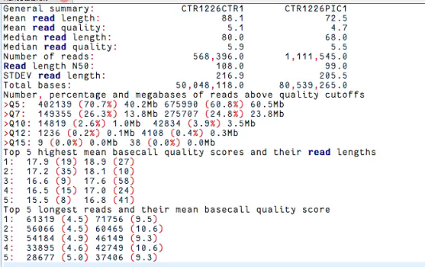
是否要过滤不太清楚：NanoComp、Filtlong、nanofilt
conda install -c bioconda nanofilt
eg：
gunzip -c reads.fastq.gz | NanoFilt -q 10 -l 500 --headcrop 50 | minimap2 genome.fa - | samtools sort -O BAM -@24 -o alignment.bam -
gunzip -c reads.fastq.gz | NanoFilt -q 12 --headcrop 75 | gzip > trimmed-reads.fastq.gz

wget http://gtrnadb.ucsc.edu/genomes/eukaryota/Hsapi38/hg38-tRNAs.fa
samtools faidx hg38-tRNAs.fa
bwa index hg38-tRNAs.fa
java -jar /home/chen/jiangjing/soft/nanoRMS/epinano_RMS/picard.jar CreateSequenceDictionary REFERENCE=hg38-tRNAs.fa OUTPUT=hg38-tRNAs.fa.dict

python3 /home/chen/jiangjing/soft/nanoRMS/epinano_RMS/epinano_rms.py -R /home/chen/jiangjing/00.db/mm39/GtRNAdb_fa/mm39-tRNAs.fa -b CTR1226CTR1_sort.bam -s /home/chen/jiangjing/soft/nanoRMS/epinano_RMS/sam2tsv.jar

Rscript --vanilla /home/chen/jiangjing/soft/nanoRMS/predict_rna_mod/Pseudou_prediction_pairedcondition_transcript.R -f CTR1226CTR1.per.site.baseFreq.csv -s CTR1226PIC1.per.site.baseFreq.csv -p hg38_trna.tsv

multi_to_single_fast5 -i fast5/ -s multi_fast5 --recursive -t 6

/home/chen/jiangjing/soft/nanoRMS/per_read/get_freq.py -f /home/chen/jiangjing/00.db/hg38/hg38-tRNAs.fa -b Paired_comparison_altering_sites_pU_predictions.bed -o Paired_comparison_altering_sites_pU_predictions.bed.tsv.gz -1 /home/chen/jiangjing/02.nanoRMS/CTR1226CTR1/fast5/*.fast5.bam -2 /home/chen/jiangjing/02.nanoRMS/CTR1226PIC1/fast5/*.fast5.bam

